Computer Architecture Lab
(EL-2012)
LABORATORY REPORT

Fall 2026

(Lab#7)
Implementation of ALU

Student Name: Syed Muhammad Shuja Abbas Naqvi Roll No:24I-6539 Section:A

Date performed: 10th October, 2026

MARKS AWARDED: ________ / 10

Signature and date of Instructor: _________________
Lab Instructors: Dr. Nasir Ali Shah, Engr. Fasih Ahmad

______________________________________________________________________________________________________________________________________________________

NATIONAL UNIVERSITY OF COMPUTER AND EMERGING SCIENCES, ISLAMABAD
Prepared by: | Fasih Ahmad |  | Version: 1.0
Verified by: | Dr. Nasir Ali Shah |  | Updated: Fall 2026

Task 1:

Description:
A 1-bit ALU was designed using Verilog to perform AND, OR, addition, and subtraction operations. A multiplexer selects the required operation according to the select lines. The circuit was tested through simulation
Code:
/*GATE:

module alu_1bit(
input A,
input B,
input carry_in,
input [1:0] Select,
input b_inv,
output Result,
output carry_out
);

wire b_new;
wire xor1;
wire sum;
wire and1;
wire and2;
wire carry;
wire and_result;
wire or_result;

xor(b_new, B, b_inv);

xor(xor1, A, b_new);
xor(sum, xor1, carry_in);

and(and1, A, b_new);
and(and2, xor1, carry_in);
or(carry, and1, and2);

and(and_result, A, B);
or(or_result, A, B);

assign Result = (Select == 2'b00) ? and_result :
(Select == 2'b01) ? or_result :
(Select == 2'b10) ? sum : 1'b0;

assign carry_out = (Select == 2'b10) ? carry : 1'b0;

endmodule
STRUCTURAL LEVEL:

module xor_gate(
input A,
input B,
output Y
);
assign Y = A ^ B;
endmodule

module and_gate(
input A,
input B,
output Y
);
assign Y = A & B;
endmodule

module or_gate(
input A,
input B,
output Y
);
assign Y = A | B;
endmodule

module alu_1bit(
input A,
input B,
input carry_in,
input [1:0] Select,
input b_inv,
output Result,
output carry_out
);

wire b_new;
wire xor1;
wire sum;
wire and1;
wire and2;
wire carry;
wire and_result;
wire or_result;

xor_gate X0(B, b_inv, b_new);

xor_gate X1(A, b_new, xor1);
xor_gate X2(xor1, carry_in, sum);

and_gate A1(A, b_new, and1);
and_gate A2(xor1, carry_in, and2);
or_gate O1(and1, and2, carry);

and_gate A3(A, B, and_result);
or_gate O2(A, B, or_result);

assign Result = (Select == 2'b00) ? and_result :
(Select == 2'b01) ? or_result :
(Select == 2'b10) ? sum : 1'b0;

assign carry_out = (Select == 2'b10) ? carry : 1'b0;

endmodule

DATAFLOW:
*/

module alu_1bit(
input A,
input B,
input carry_in,
input [1:0] Select,
input b_inv,
output reg Result,
output reg carry_out
);

wire b_new;
wire [1:0] arithmetic_result;

assign b_new = B ^ b_inv;
assign arithmetic_result = A + b_new + carry_in;

always @(*) begin
carry_out = 1'b0;

case (Select)
2'b00: Result = A & B;
2'b01: Result = A | B;
2'b10: begin
Result = arithmetic_result[0];
carry_out = arithmetic_result[1];
end
default: Result = 1'b0;
endcase
end

endmodule

module tb_alu_1bit;

reg A;
reg B;
reg carry_in;
reg [1:0] Select;
reg b_inv;

wire Result;
wire carry_out;

alu_1bit dut (
.A(A),
.B(B),
.carry_in(carry_in),
.Select(Select),
.b_inv(b_inv),
.Result(Result),
.carry_out(carry_out)
);

initial begin

A, B, carry_in, Select, b_inv, Result, carry_out);

Select = 2'b00;
b_inv = 0;
carry_in = 0;
A = 0; B = 0;
#10;
A = 0; B = 1;
#10;
A = 1; B = 0;
#10;
A = 1; B = 1;
#10;

Select = 2'b01;
A = 0; B = 0;
#10;
A = 0; B = 1;
#10;
A = 1; B = 0;
#10;
A = 1; B = 1;
#10;

Select = 2'b10;
b_inv = 0;
A = 0; B = 0; carry_in = 0;
#10;
A = 0; B = 1; carry_in = 0;
#10;
A = 1; B = 0; carry_in = 0;
#10;
A = 1; B = 1; carry_in = 0;
#10;
A = 1; B = 1; carry_in = 1;
#10;

b_inv = 1;
carry_in = 1;
A = 0; B = 0;
#10;
A = 0; B = 1;
#10;
A = 1; B = 0;
#10;
A = 1; B = 1;
#10;

end

endmodule

Output:

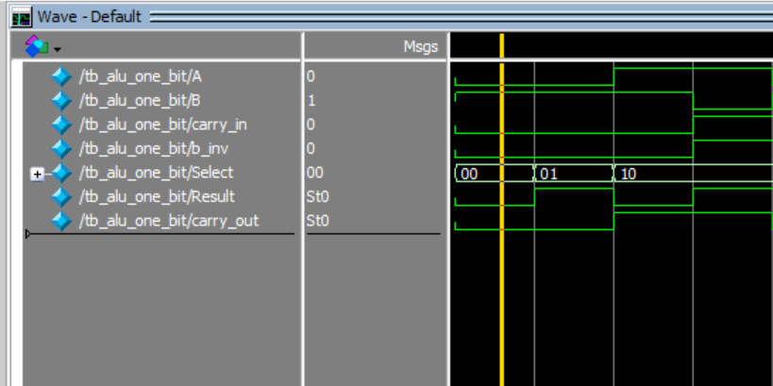

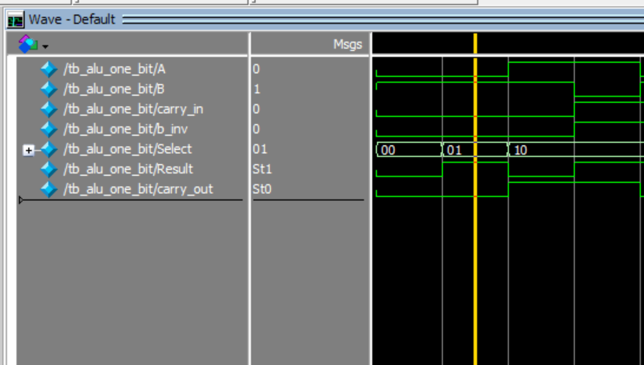

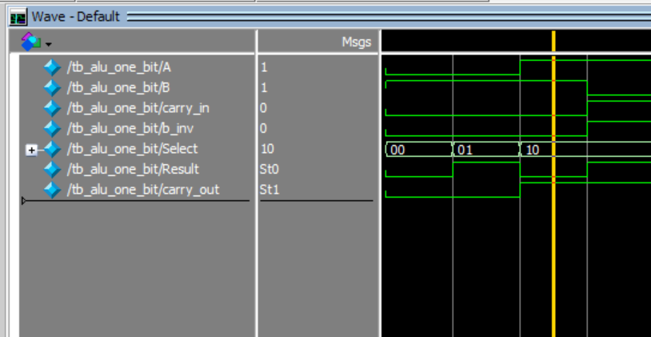
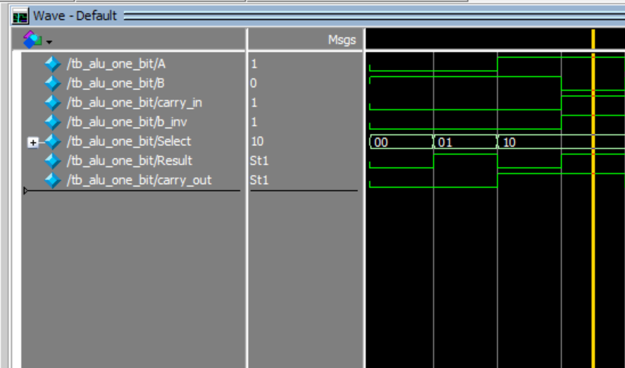
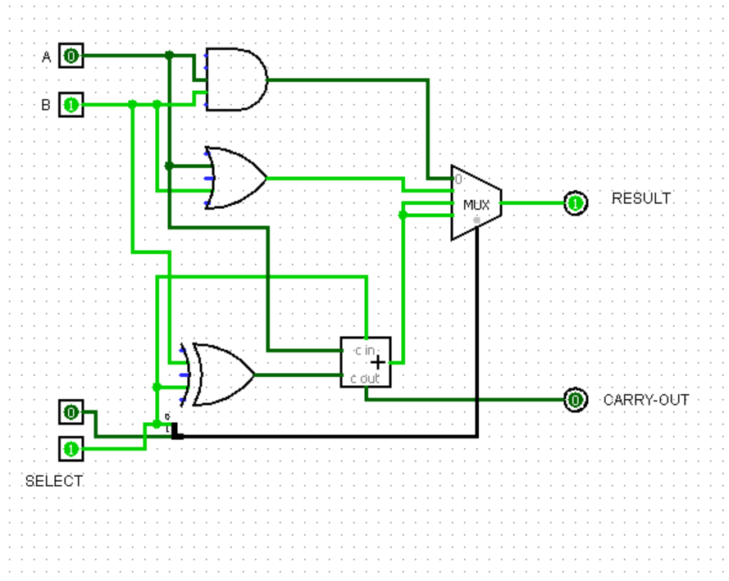

Select | Operation | A | B | Carry in | B inv | Result | Carry out
00 | AND | 1 | 1 | 0 | 0 | 1 | 0
00 | AND | 1 | 0 | 0 | 0 | 0 | 0
01 | OR | 0 | 1 | 0 | 0 | 1 | 0
01 | OR | 0 | 0 | 0 | 0 | 0 | 0
10 | ADD | 1 | 1 | 0 | 0 | 0 | 1
10 | ADD | 0 | 1 | 0 | 0 | 1 | 0
10 | SUB | 1 | 0 | 1 | 1 | 1 | 1
10 | SUB | 0 | 1 | 1 | 1 | 1 | 0

Task 2:

Description:
A 4-bit ALU was implemented by connecting four 1-bit ALUs in cascade. It performs ADD, SUB, AND, OR, and SLT operations based on the select inputs. The carry, sign, zero, and overflow flags were also implemented and tested using a testbench.
Code:
module alu_1bit(
input A,
input B,
input carry_in,
input [1:0] Select,
input b_inv,
input Less,
output reg Result,
output carry_out
);

wire B_new;
wire Sum;
wire Carry;

assign B_new = B ^ b_inv;
assign {Carry, Sum} = A + B_new + carry_in;
assign carry_out = Carry;

always @(*) begin
case (Select)
2'b00: Result = A & B;
2'b01: Result = A | B;
2'b10: Result = Sum;
2'b11: Result = Less;
default: Result = 1'b0;
endcase
end

endmodule

module alu_4bit(
input [3:0] A,
input [3:0] B,
input [1:0] Select,
input b_inv,
output [3:0] Result,
output CF,
output SF,
output ZF,
output OF
);

wire [4:0] C;
wire [3:0] Less;
wire [3:0] Sub_Result;
assign C[0] = b_inv;
assign Sub_Result = A + (~B) + 1'b1;
assign Less[0] = ($signed(A) < $signed(B));
assign Less[1] = 1'b0;
assign Less[2] = 1'b0;
assign Less[3] = 1'b0;

alu_1bit bit0(
A[0], B[0], C[0], Select, b_inv,
Less[0], Result[0], C[1]
);

alu_1bit bit1(
A[1], B[1], C[1], Select, b_inv,
Less[1], Result[1], C[2]
);

alu_1bit bit2(
A[2], B[2], C[2], Select, b_inv,
Less[2], Result[2], C[3]
);

alu_1bit bit3(
A[3], B[3], C[3], Select, b_inv,
Less[3], Result[3], C[4]
);

assign CF = C[4];
assign SF = Result[3];
assign ZF = (Result == 4'b0000);
assign OF = C[3] ^ C[4];

endmodule

module tb_alu_4bit;

reg [3:0] A;
reg [3:0] B;
reg [1:0] Select;
reg b_inv;

wire [3:0] Result;
wire CF, SF, ZF, OF;

alu_4bit uut(
.A(A),
.B(B),
.Select(Select),
.b_inv(b_inv),
.Result(Result),
.CF(CF),
.SF(SF),
.ZF(ZF),
.OF(OF)
);

initial begin

A=4'b1010; B=4'b1100;
Select=2'b00; b_inv=0; #10;

A=4'b1010; B=4'b1100;
Select=2'b01; b_inv=0; #10;

A=4'b0011; B=4'b0010;
Select=2'b10; b_inv=0; #10;

A=4'b0101; B=4'b0011;
Select=2'b10; b_inv=1; #10;

A=4'b1101; B=4'b0010;
Select=2'b11; b_inv=1; #10;

A=4'b0101; B=4'b0101;
Select=2'b10; b_inv=1; #10;

end

endmodule

Output:
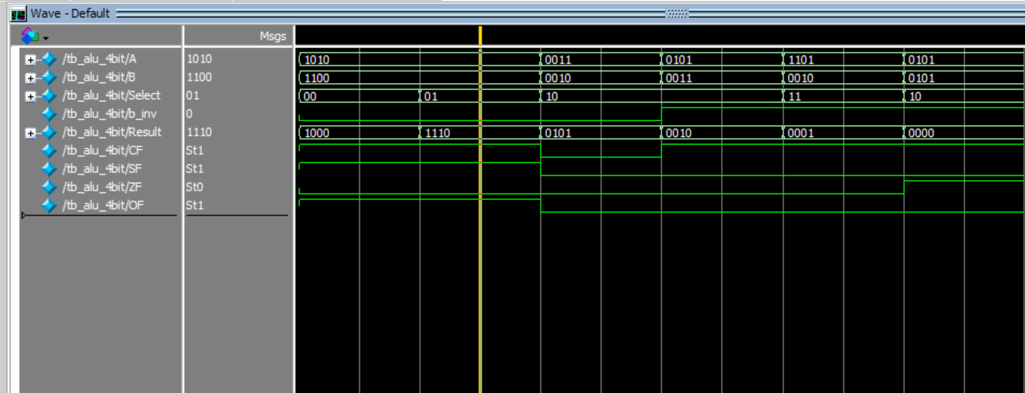

Task 3:

Description:
A parameterized ALU was designed to support different input and output bit-widths. It performs addition, subtraction, AND, OR, NOT, and XOR operations according to the control signal. The design was tested using a Verilog testbench to verify its operations.
Code:
module parameterized_alu #(parameter n = 4)(
input [n-1:0] a,
input [n-1:0] b,
input [2:0] select,
output reg [n-1:0] result
);

always @(*) begin
case (select)
3'b000: result = a + b;
3'b001: result = a - b;
3'b010: result = a & b;
3'b011: result = a | b;
3'b100: result = ~a;
3'b101: result = a ^ b;
default: result = 0;
endcase
end

endmodule

module tb_parameterized_alu;

parameter n = 4;

reg [n-1:0] a;
reg [n-1:0] b;
reg [2:0] select;

wire [n-1:0] result;

parameterized_alu #(n) uut(
.a(a),
.b(b),
.select(select),
.result(result)
);

initial begin

a = 4'b0101;
b = 4'b0011;

select = 3'b000;
#10;
select = 3'b001;
#10;
select = 3'b010;
#10;
select = 3'b011;
#10;
select = 3'b100;
#10;
select = 3'b101;
#10;

end

endmodule

Output:
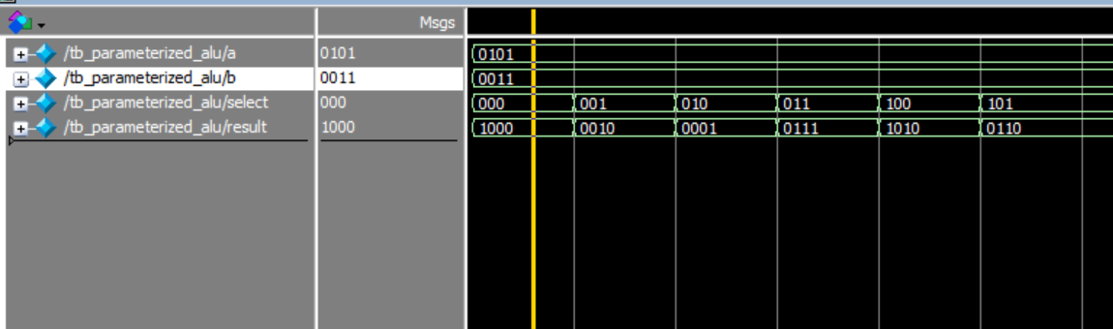
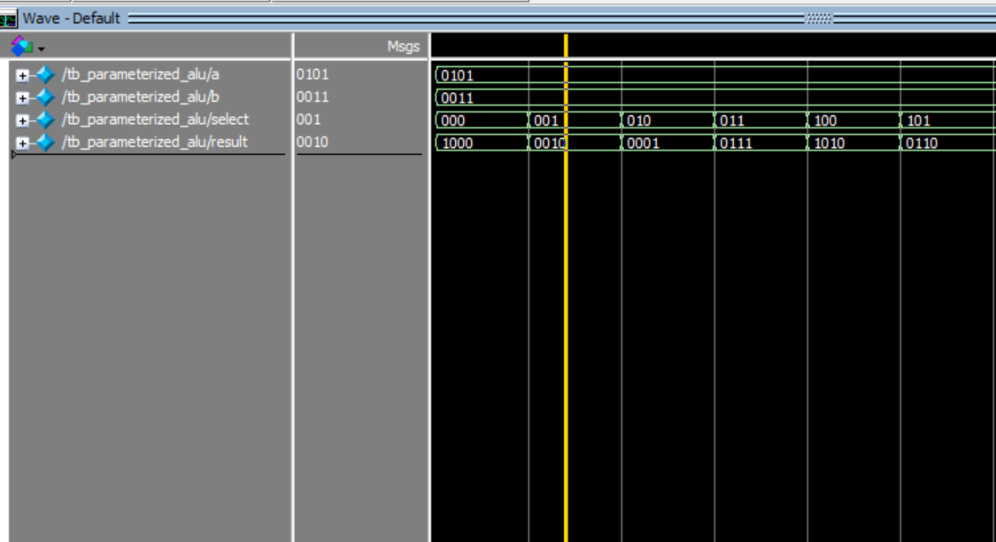
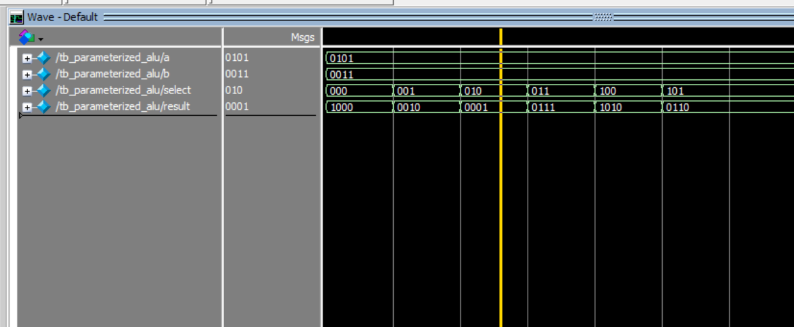
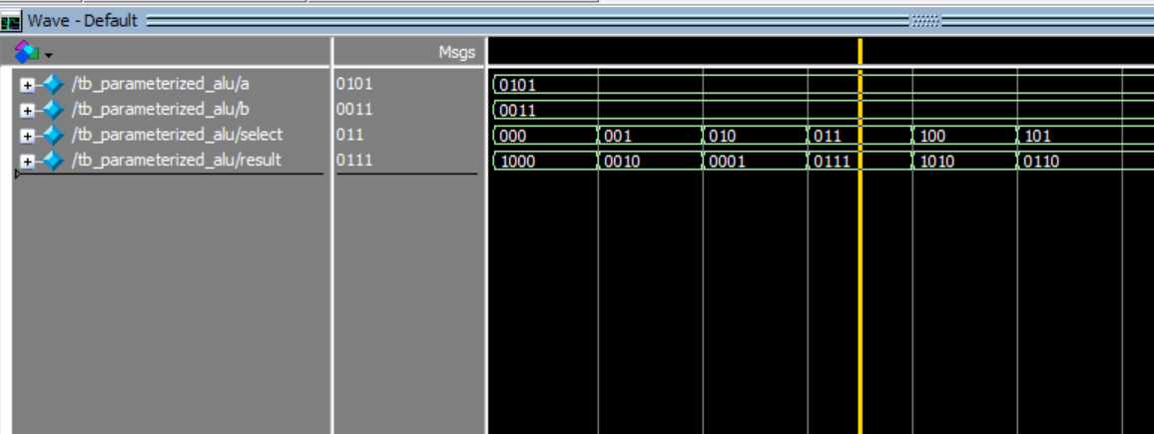
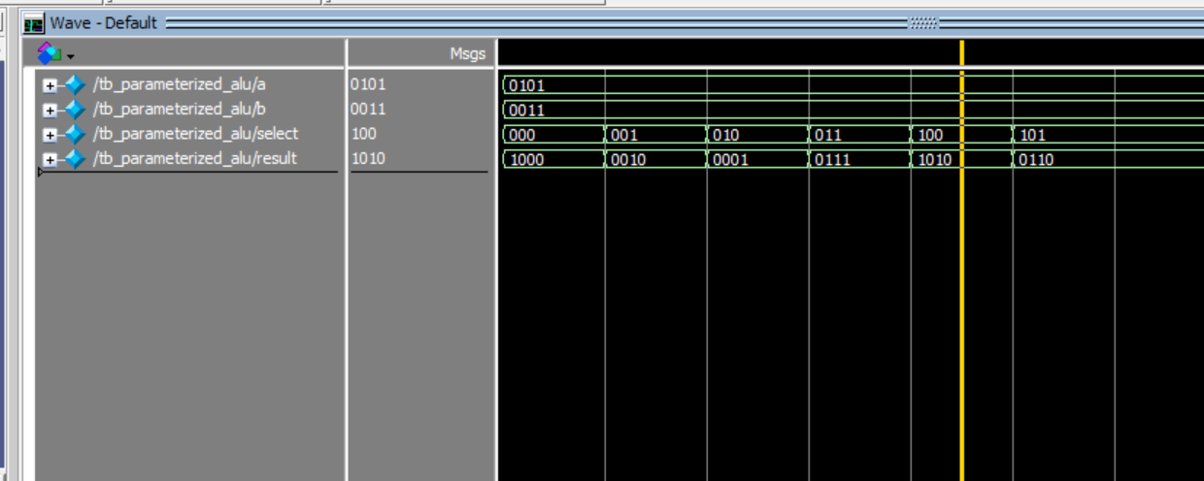
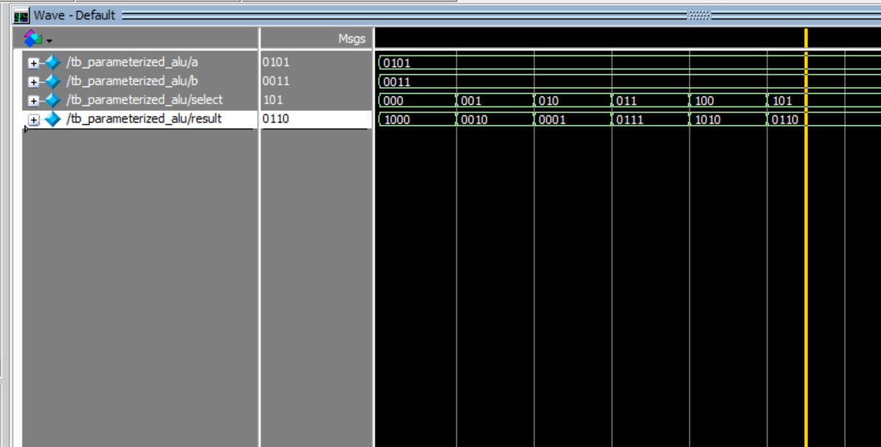

Task 4:

Description:
A 32-bit ALU was designed to perform arithmetic, logical, comparison, and shifting operations using a 4-bit control signal. It supports ADD, SUB, AND, OR, XOR, SLT, SLTU, SLL, SRL, and SRA operations. A zero flag was included to indicate when the result is zero, and the design was verified through simulation
Code:
module alu_32bit(
input [31:0] a,
input [31:0] b,
input [3:0] alu_op,
output reg [31:0] result,
output zero
);

always @(*) begin
case (alu_op)

4'b0000: result = a + b;
4'b0001: result = a - b;
4'b0010: result = a & b;
4'b0011: result = a | b;
4'b0100: result = a ^ b;

4'b0101: begin
if ($signed(a) < $signed(b))
result = 32'd1;
else
result = 32'd0;
end

4'b0110: begin
if (a < b)
result = 32'd1;
else
result = 32'd0;
end

4'b0111: result = a << b[4:0];
4'b1000: result = a >> b[4:0];
4'b1001: result = $signed(a) >>> b[4:0];

default: result = 32'b0;

endcase
end

assign zero = (result == 32'b0);

endmodule

module tb_alu_32bit;

reg [31:0] a;
reg [31:0] b;
reg [3:0] alu_op;

wire [31:0] result;
wire zero;

alu_32bit uut(
.a(a),
.b(b),
.alu_op(alu_op),
.result(result),
.zero(zero)
);

initial begin

a = 32'd10;
b = 32'd5;
alu_op = 4'b0000;
#10;

a = 32'd10;
b = 32'd10;
alu_op = 4'b0001;
#10;

a = 32'h0000000F;
b = 32'h00000003;
alu_op = 4'b0010;
#10;

a = 32'h0000000F;
b = 32'h00000003;
alu_op = 4'b0011;
#10;

a = 32'h0000000F;
b = 32'h00000003;
alu_op = 4'b0100;
#10;
a = -32'sd5;
b = 32'd3;
alu_op = 4'b0101;
#10;
a = 32'd3;
b = 32'd5;
alu_op = 4'b0110;
#10;
a = 32'd1;
b = 32'd3;
alu_op = 4'b0111;
#10;
a = 32'd16;
b = 32'd2;
alu_op = 4'b1000;
#10;
a = 32'hfffffff8;
b = 32'd1;
alu_op = 4'b1001;
#10;
end

endmodule

Output:
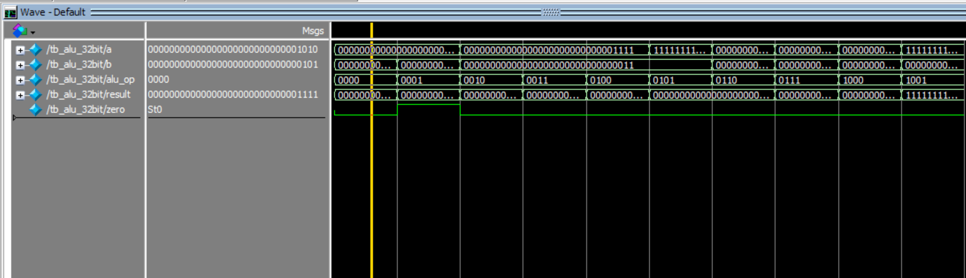
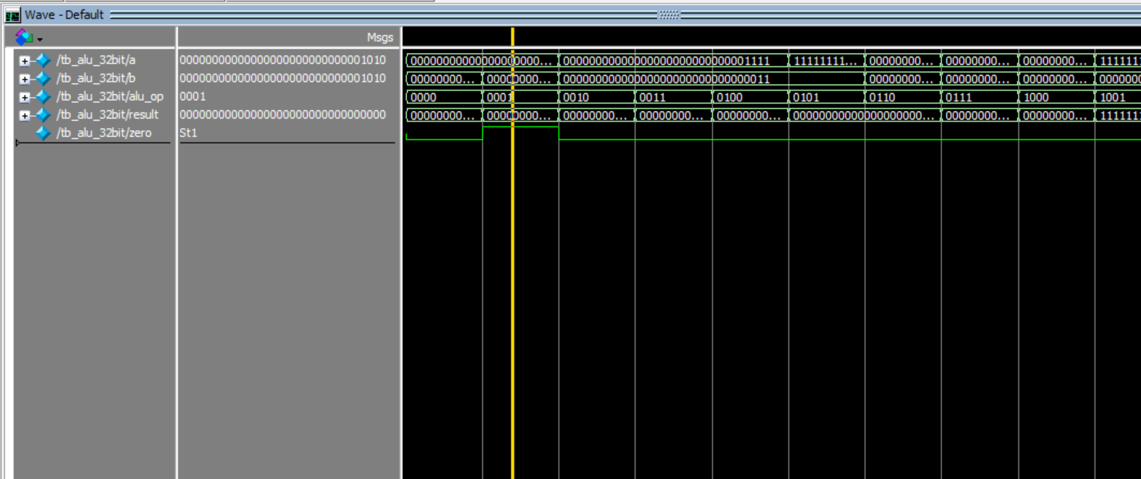
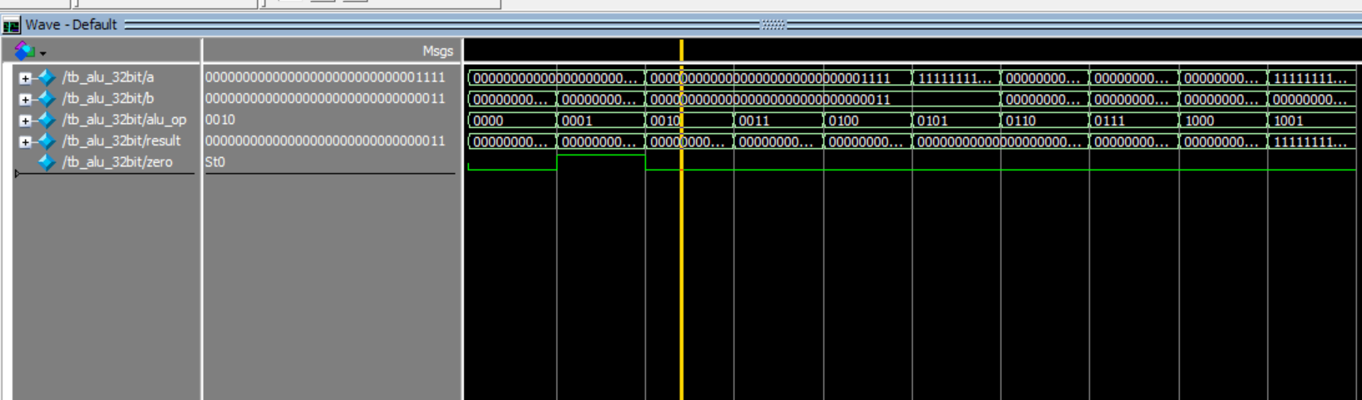
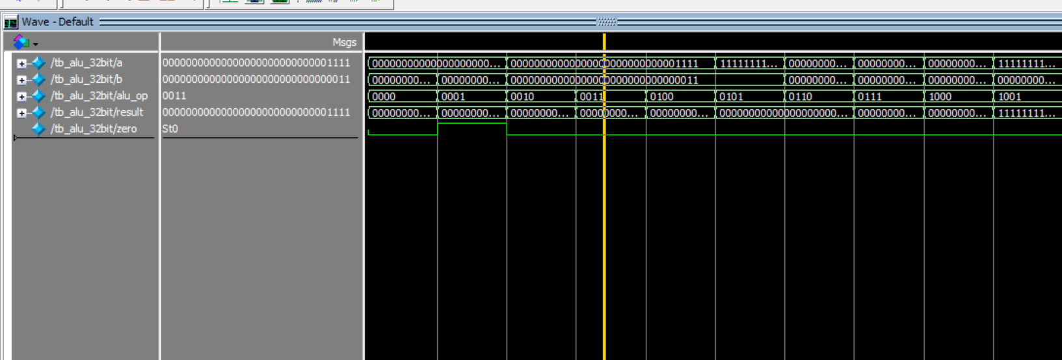
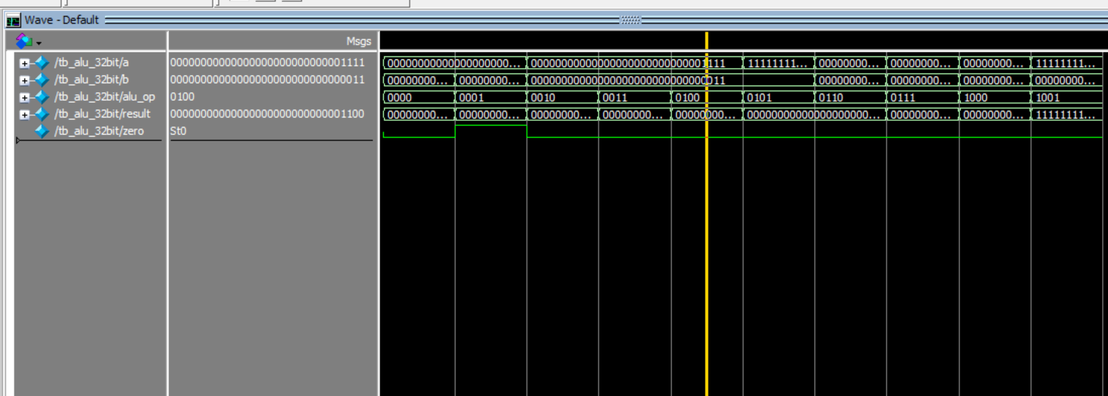
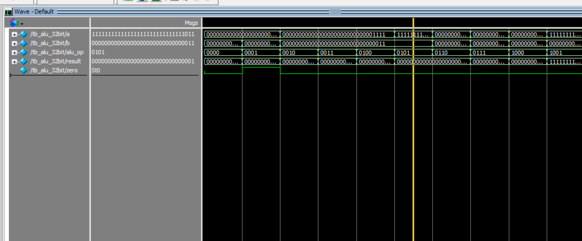
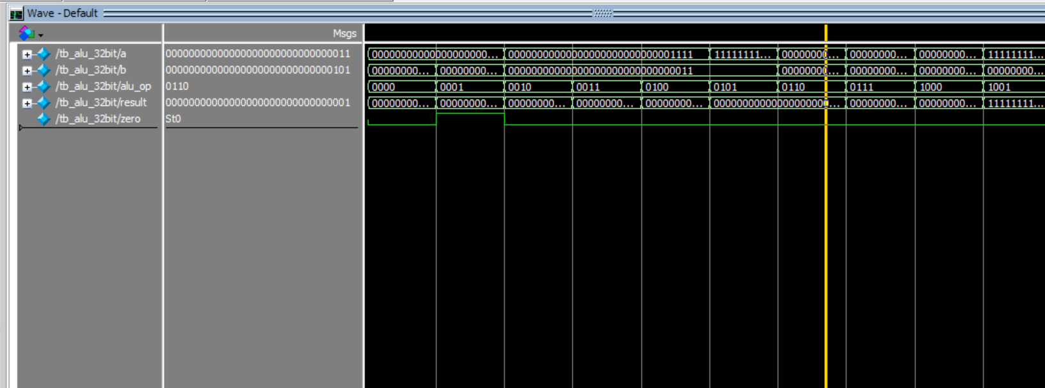
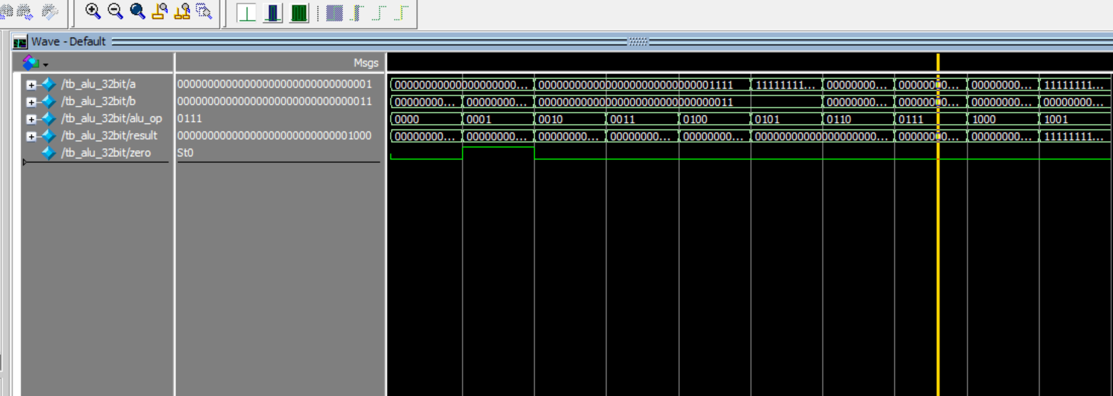
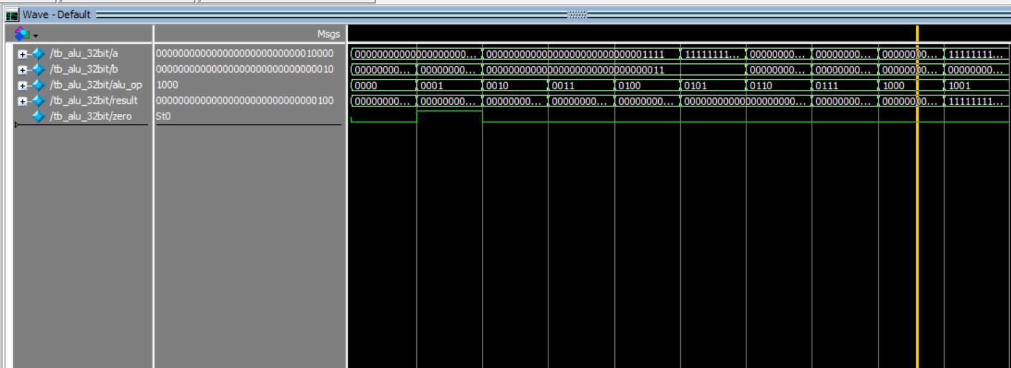
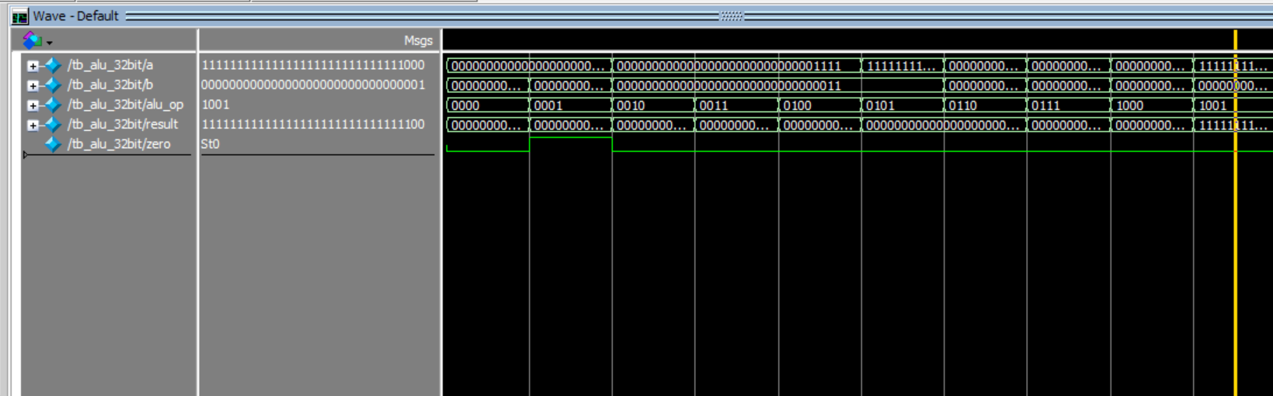

Task 5:

Description:
Logisim implementation of the above 32 bit ALU
Output:
